Sunday 5 June 2022
Pentecost Sunday
This service for all ages is based on listening to the prophetic voices in Aotearoa New Zealand of Colin McCahon and James K Baxter, as explored by John Weir in “The Spirituality of James K Baxter” and Rev Rob Yule in “How the light gets in: The Christian Art of Colin McCahon”.

Notes regarding preparation of stations:
In setting up the stations, find spaces where people have space to reflect. On each table, have the painting printed on to card (about A4 size) and preferably placed on a small easel (these are often available at shops like Look Sharp and become a useful resource to tuck away). Have the words to reflect on copied so there are enough for all at the space to have their own. Have pens available in case people want to write down their responses.

Prayer before worship:
Holy Spirit, rain down on this place. Let our souls drink your goodness
Let our hearts overflow. Holy Spirit, rain down on this place!

Welcome

Call to Worship:
Song to the Holy Spirit – James K Baxter

Lord, Holy Spirit,
You blow like the wind in a thousand paddocks,
Inside and outside the fences,
You blow where you wish to blow.

Lord, Holy Spirit,
You are the sun who shines on the little plant,
You warm him gently, you give him life,
You raise him up to become a tree with many leaves.

Lord, Holy Spirit,
You are as the mother eagle with her young,
Holding them in peace under your feathers.
On the highest mountain you have built your nest,
Above the valley, above the storms of the world,
Where no hunter ever comes.

Lord, Holy Spirit,
You are the bright cloud in whom we hide,
In whom we know already that the battle has been won.
You bring us to our Brother Jesus
To rest our heads upon his shoulder.

Lord, Holy Spirit,
You are the kind fire who does not cease to burn,
Consuming us with flames of love and peace,
Driving us out like sparks to set the world on fire.

Lord, Holy Spirit,
In the love of friends you are building a new house,
Heaven is with us when you are with us.
You are singing your song in the hearts of the poor.
Guide us, wound us, heal us. Bring us to the Father.

Songs of Worship: Come, now is the time to worship
Holy Spirit come

We light the candle of Pentecost
A red candle is lit, preferably by a child who then leads the response -red is a colour we use in Pentecost, symbolising action, fire, love, joy and spiritual awakening.

Today is Pentecost Sunday
We celebrate the Holy Spirit,
Always moving in our midst
Today is Pentecost Sunday
We celebrate the Holy Spirit
Leading us into new places of grace.

Opening Prayer
Loving God, like those first disciples
we too have walked the hillsides and pathways and we too have hid in fear, in an upper room.
There have been times when we have been in awe of your resurrection Jesus
and there have been times when we have not known what to believe.
We too are in need of your Holy Spirit
to inflame our hearts and to encourage us out into life.
So, rushing Wind of the Spirit, breathe new life into us too
where we expect it and where we do not
Warming Sun Spirit,
warm us with your life and raise us up
Mother eagle Spirit,
hold us in your peace in places of safety.
Bright cloud, Spirit,
be the place we can rest when we are weary
Kind fire of the Spirit,
burn away our fears.
Lord, Holy Spirit,
build anew in us your people and sing your song through us

Birthday Basket

Offering and Dedication
God of Amazement and Wonder, you have been preparing the way for us throughout time. You sent people like the prophet Joel and Peter to guide our spiritual journey. On this day of Pentecost, we celebrate the power of the Holy Spirit. Sometimes confused but often in awe, we watch the everyday miracles experienced all around us. All things are possible with you, O God. We trust that this offering will foster the miracles and the possibilities that you have in store for this church community. We await with hearts already filled in amazement and wonder at your ways. Come Holy Spirit, come! Amen.
Copyright © 2022 David S. Bell. Reprinted with permission from www.DavidSBell.org.

Bible Reading: Acts 2:1-21
2When the day of Pentecost had come, they were all together in one place. ²And suddenly from heaven there came a sound like the rush of a violent wind, and it filled the entire house where they were sitting. ³Divided tongues, as of fire, appeared among them, and a tongue rested on each of them. ⁴All of them were filled with the Holy Spirit and began to speak in other languages, as the Spirit gave them ability.
⁵Now there were devout Jews from every nation under heaven living in Jerusalem. ⁶And at this sound the crowd gathered and was bewildered, because each one heard them speaking in the native language of each. ⁷Amazed and astonished, they asked, “Are not all these who are speaking Galileans? ⁸And how is it that we hear, each of us, in our own native language? ⁹Parthians, Medes, Elamites, and residents of Mesopotamia, Judea and Cappadocia, Pontus and Asia, ¹⁰Phrygia and Pamphylia, Egypt and the parts of Libya belonging to Cyrene, and visitors from Rome, both Jews and proselytes, ¹¹Cretans and Arabs—in our own languages we hear them speaking about God’s deeds of power.” ¹²All were amazed and perplexed, saying to one another, “What does this mean?” ¹³But others sneered and said, “They are filled with new wine.”
¹⁴But Peter, standing with the eleven, raised his voice and addressed them, “Men of Judea and all who live in Jerusalem, let this be known to you, and listen to what I say. ¹⁵Indeed, these are not drunk, as you suppose, for it is only nine o’clock in the morning. ¹⁶No, this is what was spoken through the prophet Joel: ¹⁷‘In the last days it will be, God declares, that I will pour out my Spirit upon all flesh, and your sons and your daughters shall prophesy, and your young men shall see visions, and your old men shall dream dreams. ¹⁸Even upon my slaves, both men and women, in those days I will pour out my Spirit; and they shall prophesy. ¹⁹And I will show portents in the heaven above and signs on the earth below, blood, and fire, and smoky mist. ²⁰The sun shall be turned to darkness and the moon to blood, before the coming of the Lord’s great and glorious day. ²¹Then everyone who calls on the name of the Lord shall be saved.’

God is still speaking
And we are still listening
Breath Prayer
Breath prayers have been used by Christians for centuries and can be traced back to the Desert Fathers and Mothers, a group who around the 3rd century CE, chose to leave society for a community in the desert of Egypt to seek deeper intimacy with God.

Teach a Breath Prayer for Pentecost…
As you breathe in: Thank you, God, for filling us with your Holy Spirit (take in a big breath and hold it).
As you breathe out: Send us out now to spread your Holy Spirit (let out their big breath).

Introduction to Stations

In this time of All Ages together in worship, everyone is invited to move around and explore an aspect of the work of the Holy Spirit in our lives through the lens of McCahon and/or Baxter. You may choose to spend all 30 minutes at one station, or less time at more stations. You are invited to choose the pace that suits you in this moment.
One space is especially for the younger pre-reading children.
Both Colin McCahon and James K Baxter are well known figures in our land, but their faith has often been ignored or misunderstood, a common response in our secular society. But here we take time to honour the work of God in their lives and learn from what they offer.

In this time, we will be invited to explore what it means to let the Holy Spirit be at work in our lives.

Traditionally at Easter there are 14 stations of the cross, here for Pentecost I offer 14 stations of the Spirit. You may however choose to have less stations -in which case, try to choose a variety of areas being addressed.

Each space invites you to explore the work of the Holy Spirit in a different way. Whether the Spirit is pointing us to a new kingdom, or to Jesus, or revealing God’s name, or speaking your name, calling you back or calling you to a new place, the work of the Holy Spirit may not always be comfortable, but is life giving. If one space is not helpful, simply move on to another.

Station 1: A Candle in a Dark Room, Colin McCahon,1947
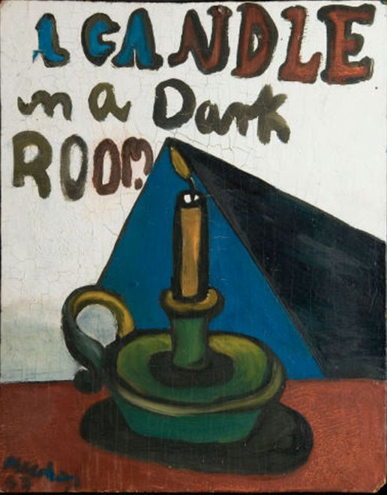
This was painted to record Colin McCahon’s first meeting with the poet James K. Baxter, demonstrating McCahon’s high esteem for Baxter. This regard was reciprocated. The poet wrote to McCahon in November 1947 ‘I think you put onto canvas something I know about N.Z. but have not learned to say. The raw vitality and brutal simplification.’ Here were two major religious artists of the post-war period who emerged from Dunedin, recognising something in each other.
Light guides, enlightens, brings hope and safety and transformation. With light, we get to see what is truly there.
Colin McCahon saw in someone else the ability to bring light into a place of darkness.

The beginning of Scripture starts with these words –

1 In the beginning God created the heavens and the earth. ² Now the earth was formless and empty, darkness was over the surface of the deep, and the Spirit of God was hovering over the waters. ³ And God said, “Let there be light,” and there was light. ⁴ God saw that the light was good, and he separated the light from the darkness.

From the beginning, the Spirit brings light into the darkness.

The Gospel of John begins with these words –

1 In the beginning was the Word, and the Word was with God, and the Word was God. ² He was with God in the beginning. ³ Through him all things were made; without him nothing was made that has been made. ⁴ In him was life, and that life was the light of all mankind. ⁵ The light shines in the darkness, and the darkness has not overcome^{[a]} it.

We are called to bring light into dark places and can do this in and through the Holy Spirit.
As you look at the painting, reflect on
- Where do you find yourself?

- How do you experience light and darkness?

- What light have you experienced through the Holy Spirit?

- Who has helped you see light in darkness?
Station 2: Gate III, Colin McCahon, 1970
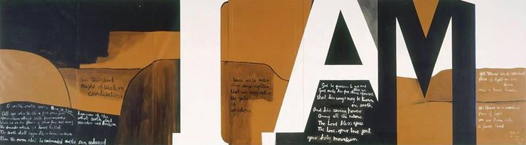

In this enormous 3 metre-high and 11 metre-long piece, ‘I AM’ is written in white and black letters, astride a stylised but recognisably New Zealand landscape. There are texts reminiscent of the biblical prophets, and there is a sense of movement from darkness on the left, heavy with foreboding, to a brighter landscape on the right.

So, we see this transition from darkness to light being marked by biblical texts and framed by the giant letters ‘I AM’, referring back to the story of Moses.

Take a Bible and read Exodus 3: 1-14

- What stands out for you, as God is revealed to Moses?

- What is God calling Moses to?

- Why does Moses need to know God’s name?

- What movement does Moses experience from darkness to light?

The title of Gate III is taken from Psalm 90:12 –
‘teach us to order our days rightly that we might enter the gates of wisdom’ -a prayer for self-awareness.

The work also includes a blessing from Psalm 67: 1-2 -
‘God be gracious to us and bless us, God make his face shine upon us that his ways may be known on earth and his saving power among all the nations’

What better day than Pentecost to remember the way we too move from darkness toward the great I Am. We might call it conversion or transformation or becoming.

- Ponder what biblical text draws you toward God.

- What brings you out of darkness into the light of Christ.

Station 3: The Promised Land, Colin McCahon, 1948

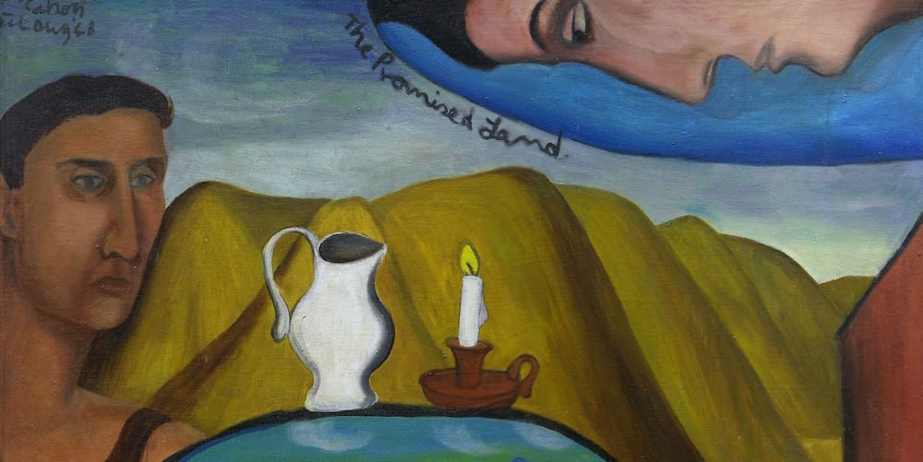

This work shows Colin’s love for the natural beauty of New Zealand, and yet a longing for a perfection that lies beyond it.

Rob Yule writes -
“Dressed in his black workman’s singlet he places himself in the painting, beside the Takaka Hill, with his red workman’s hut to the right. Superimposed on this—a painting within a painting—is a vision of a future paradise represented by the scene beyond the hill: the landscape of Golden Bay, with the hills of Takaka now in the foreground, the view towards Farewell Spit in the background, and the artist (or perhaps an angel) looking down envisioning it. McCahon is affirming more than the goodness of God’s creation. Far ahead, beyond the barren hills and toil of present experience, across the golden strand, he glimpses a promised land of fruitfulness and beauty, the almost forgotten Christian dream of an earthly millennium.”

The promised land, the new Jerusalem, a new heaven and a new earth… these visions in Scripture that call us forward in hope. Whilst they are not going to be fulfilled in this age, we are still called to work to build this kingdom. The now and the not yet are entwined.

- What longings do you hold for our land?

- How might these longings start to be enacted in the present?

- Central to this piece is a jug and candle. How might water and light be symbols of this ushering in of the new kingdom?

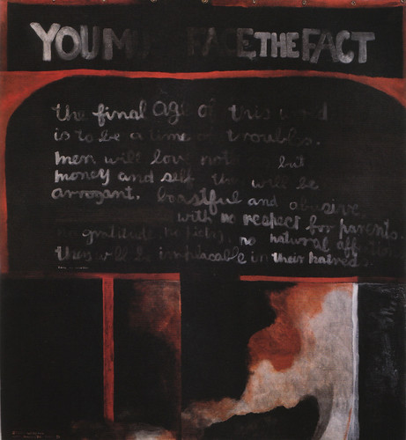
Station 4: Storm Warning, Colin McCahon 1980-81
This is an apocalyptic warning of what things will be like in the latter days, based on 2 Timothy 3:1-3.
‘YOU MUST FACE THE FACT’,
it declares,
“the final age of this world
is to be a time of troubles’:
men will love nothing but money and self,
they will be arrogant, boastful and abusive;
with no respect for parents, no gratitude,
no piety, no natural affections they will be implacable in their hatreds.”
2 Timothy 3: 1-3 reads -
But mark this: There will be terrible times in the last days. People will be lovers of themselves, lovers of money, boastful, proud, abusive, disobedient to their parents, ungrateful, unholy, without love, unforgiving, slanderous, without self-control, brutal, not lovers of the good.

McCahon gave this painting to Victoria University as a gift in 1981, but it was sold in 1999 for around $1.2 million to unidentified New Zealand collectors to cover the shortfall in the funding of the Adam Art Gallery.
Before giving this gift, he wrote, “It is a public work and I don’t want it to disappear into a private collection”, but the letter only came to light after the painting was sold.

In Romans 8: 12-17 (NIV) we read -
¹² Therefore, brothers and sisters, we have an obligation—but it is not to the flesh, to live according to it. ¹³ For if you live according to the flesh, you will die; but if by the Spirit you put to death the misdeeds of the body, you will live. ¹⁴ For those who are led by the Spirit of God are the children of God. ¹⁵ The Spirit you received does not make you slaves, so that you live in fear again; rather, the Spirit you received brought about your adoption to sonship.^{[a]} And by him we cry, “Abba,^{[b]} Father.” ¹⁶ The Spirit himself testifies with our spirit that we are God’s children. ¹⁷ Now if we are children, then we are heirs—heirs of God and co-heirs with Christ, if indeed we share in his sufferings in order that we may also share in his glory.

It seems that here in history we see what it is to live according to the flesh; the way of profit and comfort, warned of by Timothy.

- What prophetic voices do we sell out and remove from the public eye in fear that they might make us uncomfortable?
- When do we choose profit over faithfulness?

Even in a time when it was unpopular to do so, McCahon used his gift of art to explore questions of faith and doubt, meaning and despair in the context of Aotearoa New Zealand.

- What mechanisms or gifts might we use?
Station 6: A Painting for Uncle Frank, Colin McCahon, 1980
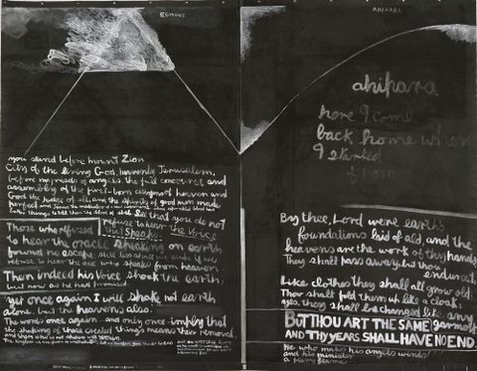
Back in the 1950s when Colin McCahon was young, he was taking the bus to work at the Auckland Art Gallery, and he told a friend that he wanted to be an evangelist. It invites us to delve into his background. Apparently, Colin worked as a youth in the orchards of Motueka, where he would visit with an artist friend Toss Woollaston, whose uncle, Frank Tosswill, was a member of the Oxford Group, which emphasised evangelical social renewal and promoted four basic ideals -absolute honesty, absolute purity, absolute unselfishness and absolute love. When Uncle Frank preached he unrolled a large scroll (over 2 metres) with diagrams and texts to illustrate his sermons. On it was the sun rising over Tasman Bay, texts in read forming radiating beams and “Almighty God” painted along the top. Colin was fascinated by this combination of image and text.

This painting for Uncle Frank has the image of Mt Taranaki and the text of the heavenly Jerusalem in Hebrews 12: 22-29 –
²² But you have come to Mount Zion, to the city of the living God, the heavenly Jerusalem. You have come to thousands upon thousands of angels in joyful assembly, ²³ to the church of the firstborn, whose names are written in heaven. You have come to God, the Judge of all, to the spirits of the righteous made perfect, ²⁴ to Jesus the mediator of a new covenant, and to the sprinkled blood that speaks a better word than the blood of Abel.
²⁵ See to it that you do not refuse him who speaks. If they did not escape when they refused him who warned them on earth, how much less will we, if we turn away from him who warns us from heaven? ²⁶ At that time his voice shook the earth, but now he has promised, “Once more I will shake not only the earth but also the heavens.”^{[e]} ²⁷ The words “once more” indicate the removing of what can be shaken—that is, created things—so that what cannot be shaken may remain.
²⁸ Therefore, since we are receiving a kingdom that cannot be shaken, let us be thankful, and so worship God acceptably with reverence and awe, ²⁹ for our “God is a consuming fire.”^{[f]}

Colin McCahon was choosing to honour someone who was important in his spiritual growth.
- Who was important in helping you understand faith?

- On this Day of Pentecost, who has helped you to understand the Holy Spirit at work in your life?

- How might you honour them and so honour God?

Station 7: This day a man is, Colin McCahon, 1970
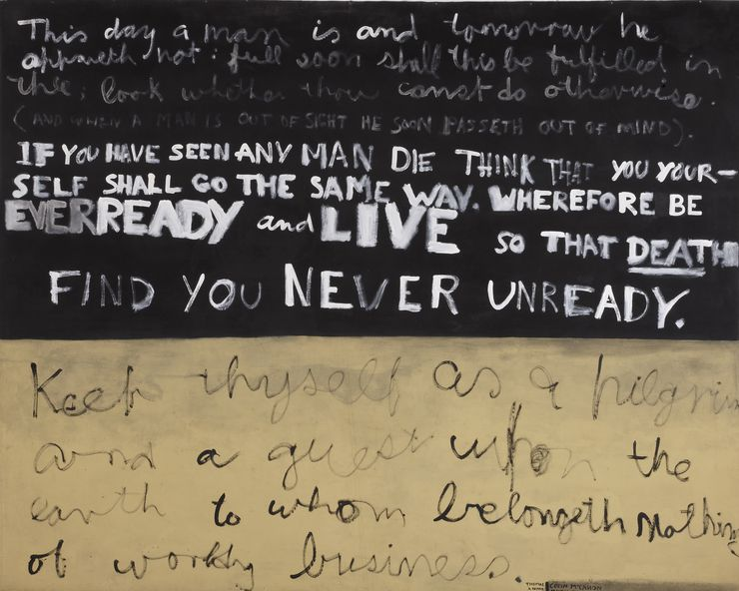
Perhaps unsurprisingly, despite Colin McCahon’s effort to incarnate the Christian message in our very own culture, this clearly recognisable dimension kept being minimised or ignored.
Perhaps because he was honest with the struggle that came with faith, it seems the kiwi public want to celebrate him but with what his artist friend Alexa Johnston called “a nagging suspicion that McCahon has somehow let us down by his being a great painter yet insisting on bringing religion into it.”

- In what ways do you leave your faith outside or bring it into your everyday activities?

But Colin McCahon kept going. He kept exploring what it meant to imitate Christ.

In this work is a quote from The Imitation of Christ, an early c15th devotional classic by Thomas A ‘Kempis –

“Keep thyself as a pilgrim and a guest upon the earth…”

- Take some time with this sentence.
- What does it mean for you to be a pilgrim?

- What does it mean for you to be a guest upon the earth?

Station 8: A Question of Faith, Colin McCahon, 1970
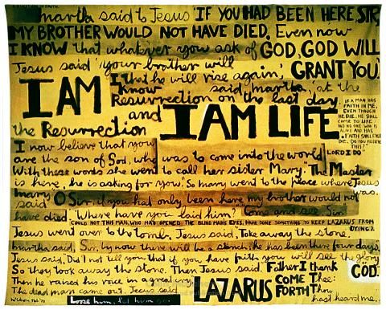
This work recounts the dialogue in John 11 of Jesus and Martha after the death of Lazarus. When Colin discovered the New English Bible, he talked about re-reading his favourite texts and “rediscovered good old Lazarus… one of the most beautiful and puzzling stories in the New Testament… it hit me BANG! At where I was: questions and answers, faith so simple and beautiful and doubts still pushing to somewhere else. It really got me down with joy and pain.”
As they talk, Martha hints at both possibility and doubt. While Martha waits for Jesus, she is aware of the what ifs in her mind. If only he had been there.
This work is dealing with the hiddenness of God, when perhaps it comes down simply to a question of faith.
We might experience times when God feels too far away. Times when we imagine how it might be different. And yet in the story of Lazarus, we see that amidst the absence, is the presence -and that is ultimately enough to be life giving.
- Have you experienced a time where God has seemed hidden or absent?

- How does Martha’s experience speak into your situation?

NB: Martha’s questions are also included in a slightly earlier 8x2m piece called Practical Religion: The resurrection of Lazarus. 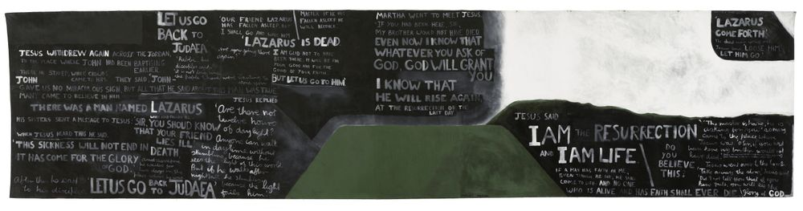

Station 9: I Paul to you Ngatimoti, Colin McCahon. 1946
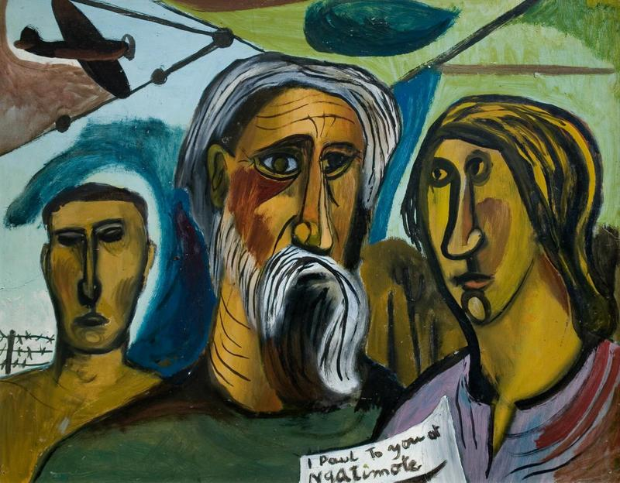
Ngatimoti is a farming locality on the Motueka River, 18 km south-west of Motueka (where Colin McCahon worked as a young man).
A Māori boy with the baptismal name of Timothy (Timoti) once carved the words “Na-Timoti” on the trunk of a tree, meaning ‘belonging to Timothy’. This was taken for the name of the settlement, and Pakeha settlers ‘corrected’ it to “Ngatimoti”. And so became this small settlement that by the time of 1941 had its own general store.
In this early work we see the concept of Paul’s letter being written to a real local community, being applied to another real local community. To the community of Ngatimoti. It is the first of his early religious paintings, depicting events from Christ’s life in a New Zealand setting.
A plane flies in the background perhaps reminiscent of the freshly ended war or perhaps simply spreading fertiliser. A barbed wire fence and farmland can also be seen, reminding them of their context. What might Colin McCahon have imagined would be spoken by Paul to this rural community near Motueka back in 1946?
- Take some time to play with this idea.

- Just as Paul wrote to many different early Christian communities, ponder what might need to be said to your faith community.

- What issues would such a letter be likely to address?

Station 10: The Lark’s Song, Colin McCahon, 1969
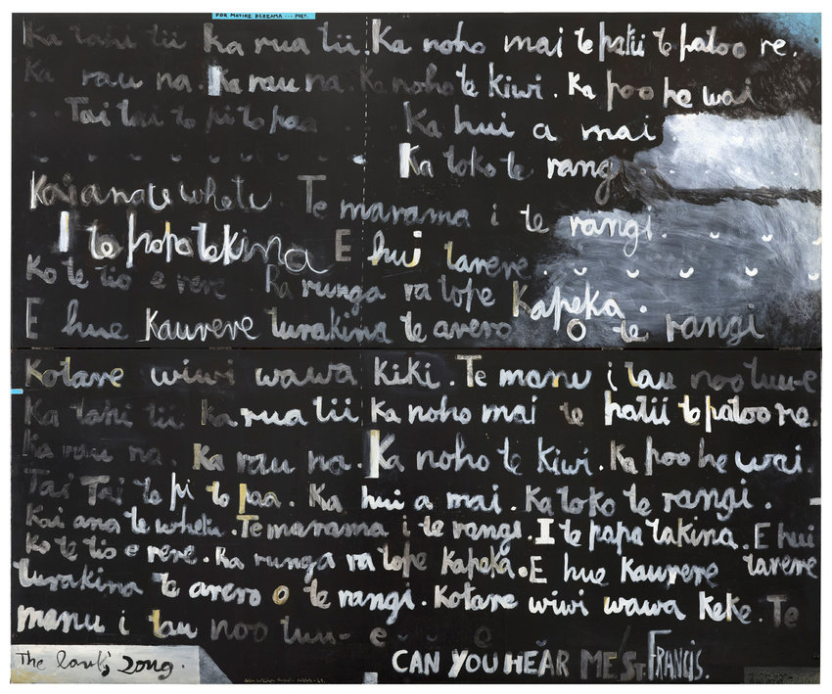
Colin McCahon grounded his faith in his New Zealand context.
When his daughter Victoria married into a Māori family, an interest in Māori spirituality was rekindled.
The Lark’s Song (1969) is based on a Māori poem by Matire Kereama.
It flows with the liquidity of a lark’s trill, soaring skyward, the lark seems to symbolise McCahon’s awareness of being a citizen of another world.
The painting concludes with an appeal, in English, to the patron saint of birds and animals: ‘Can you hear me St. Francis.’ Feeling that secular New Zealanders were not listening, he compares himself to St Francis, preaching to the birds.

Colin McCahon grappled with the way God’s hiddenness makes faith possible and yet invites doubt.
- What different birdsong can you recall? Where were you?

Psalm 19: 1-4 reminds us of the way creation declares God’s glory -
The heavens declare the glory of God;
the skies proclaim the work of his hands.
Day after day they pour forth speech;
night after night they reveal knowledge.
They have no speech, they use no words;
no sound is heard from them.
Yet their voice^{[b]} goes out into all the earth,
their words to the ends of the world.

- How does creation draw you closer to God?

- How might caring for creation involve you in the work of the Holy Spirit?

Station 11: Your space to reflect on the works of Colin McCahon and the work of the Holy Spirit in your life.

At this station you are invited to take a copy of a painting that attracts your attention and then take a card with the questions and apply them to the piece of art you have chosen. Sit with the questions that best suit you.

Questions:
- What stands out for you in this piece of art?

- Why do you think it does?

- What do you think the art is trying to say?

- Is there a place you find yourself in the work?

- Is there a place you find God in the work?

- Is there something God is speaking to you through it?
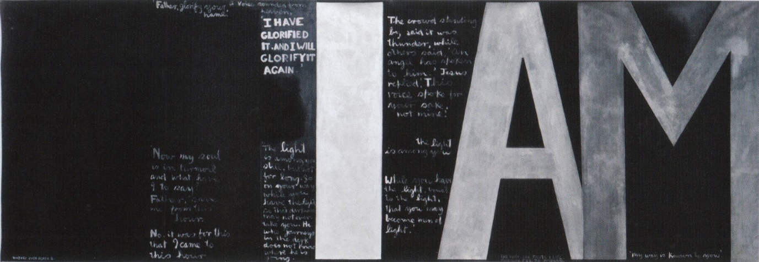
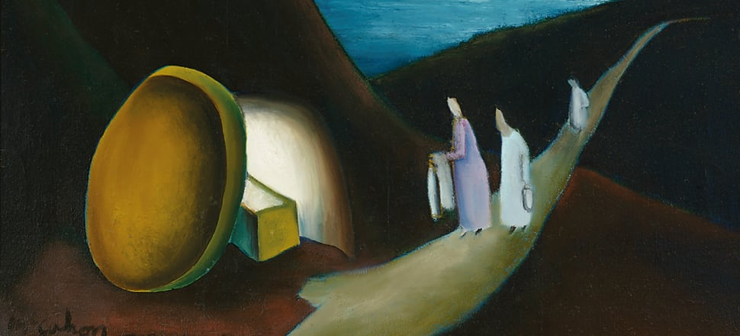
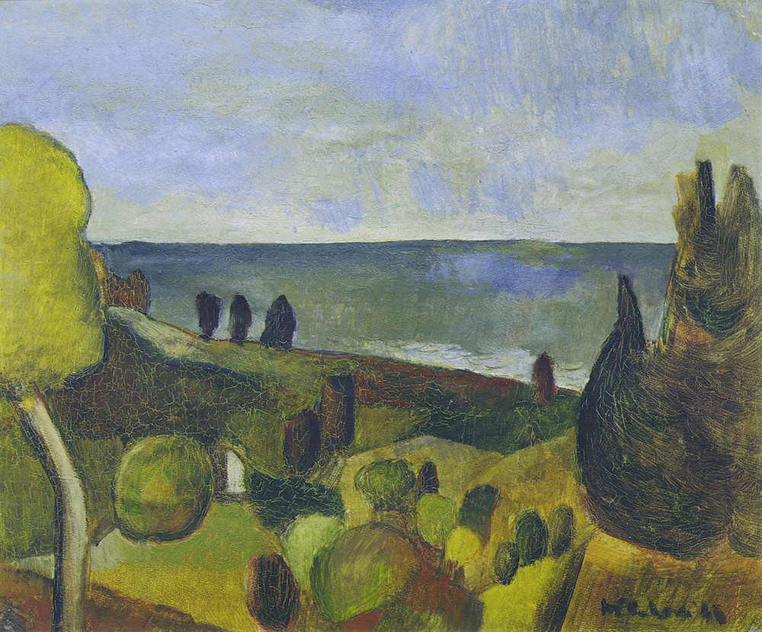

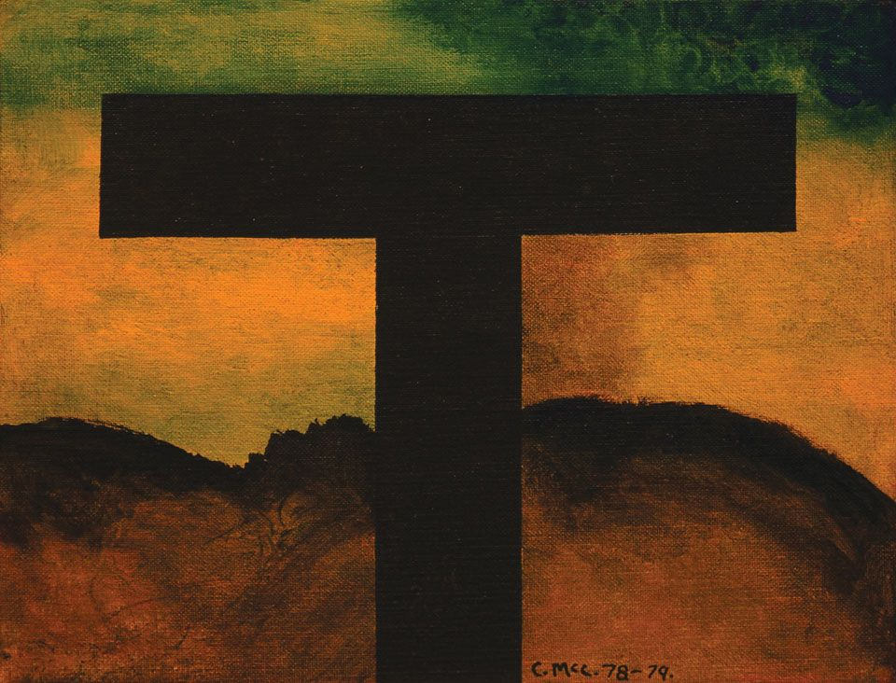
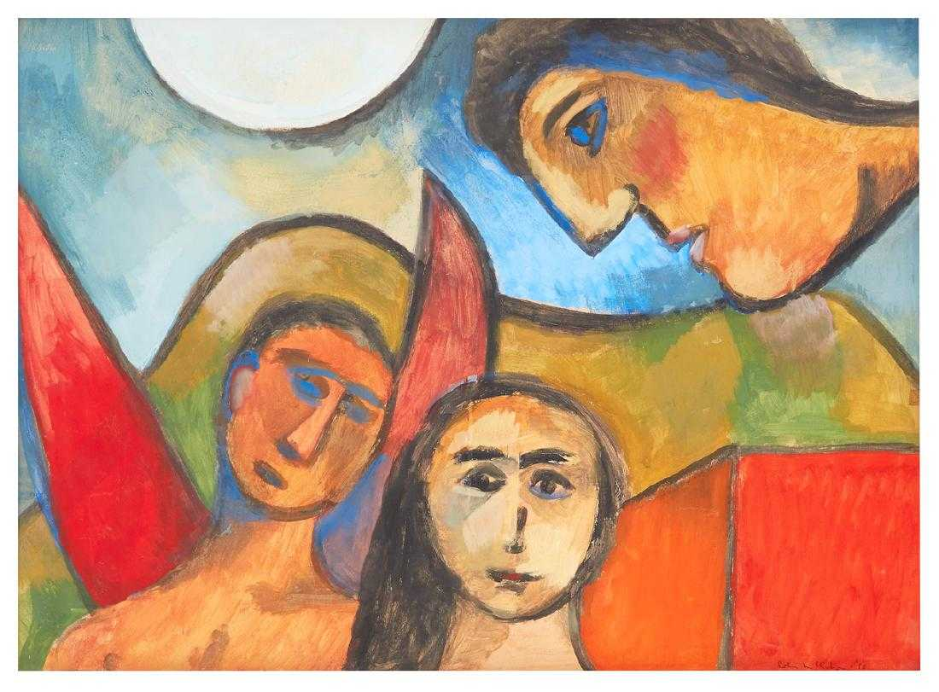
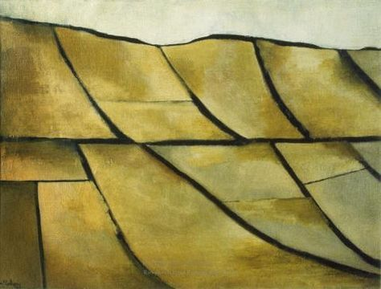
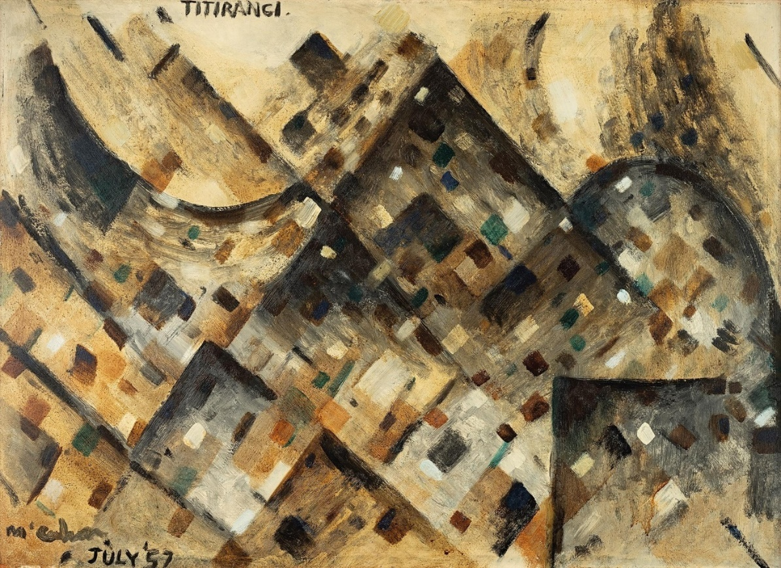

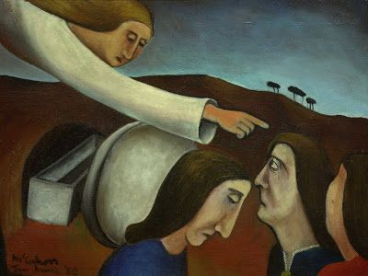
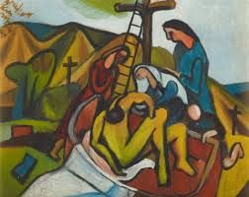
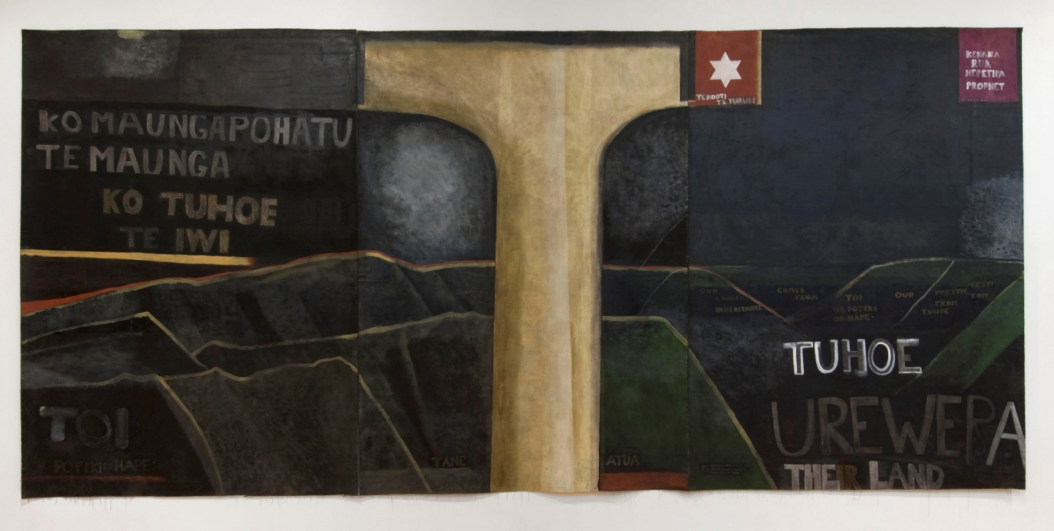
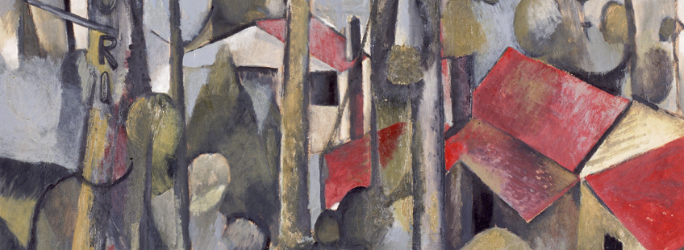

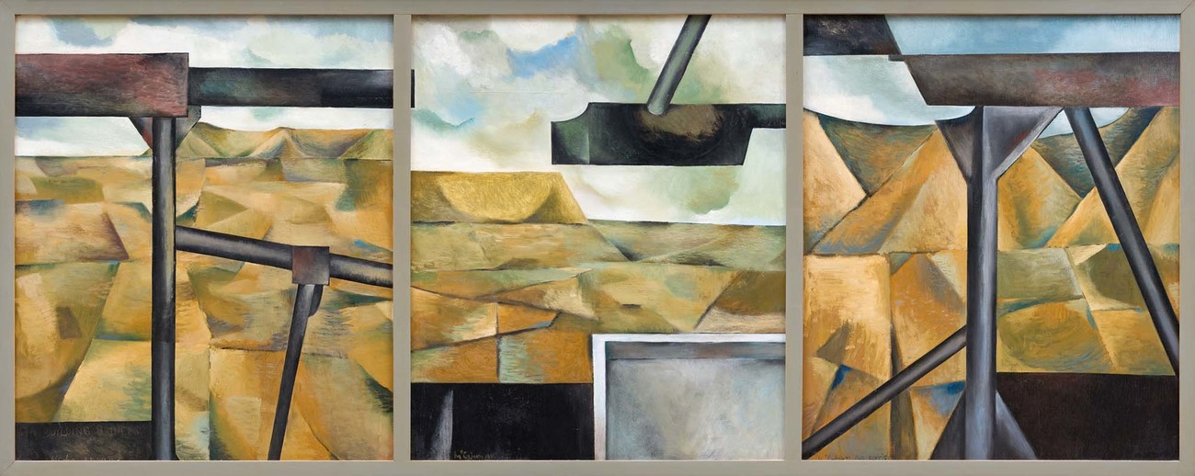

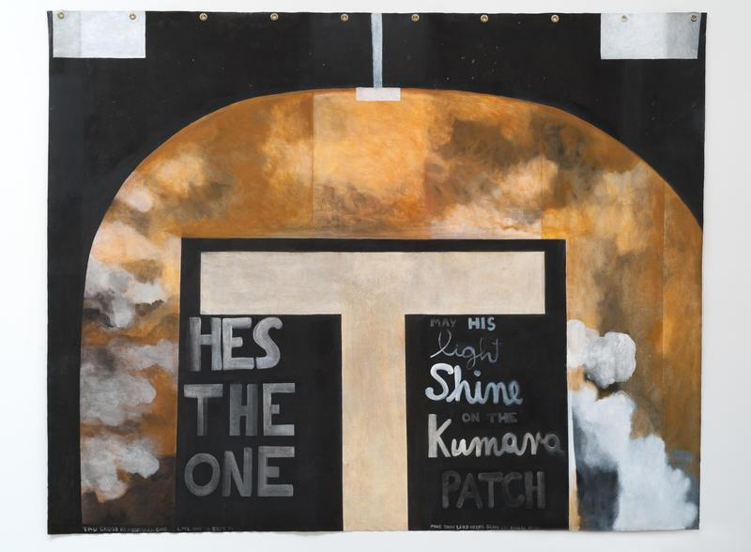
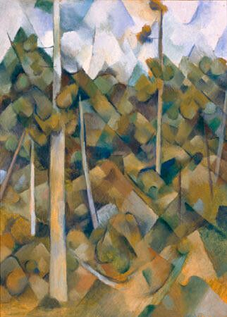
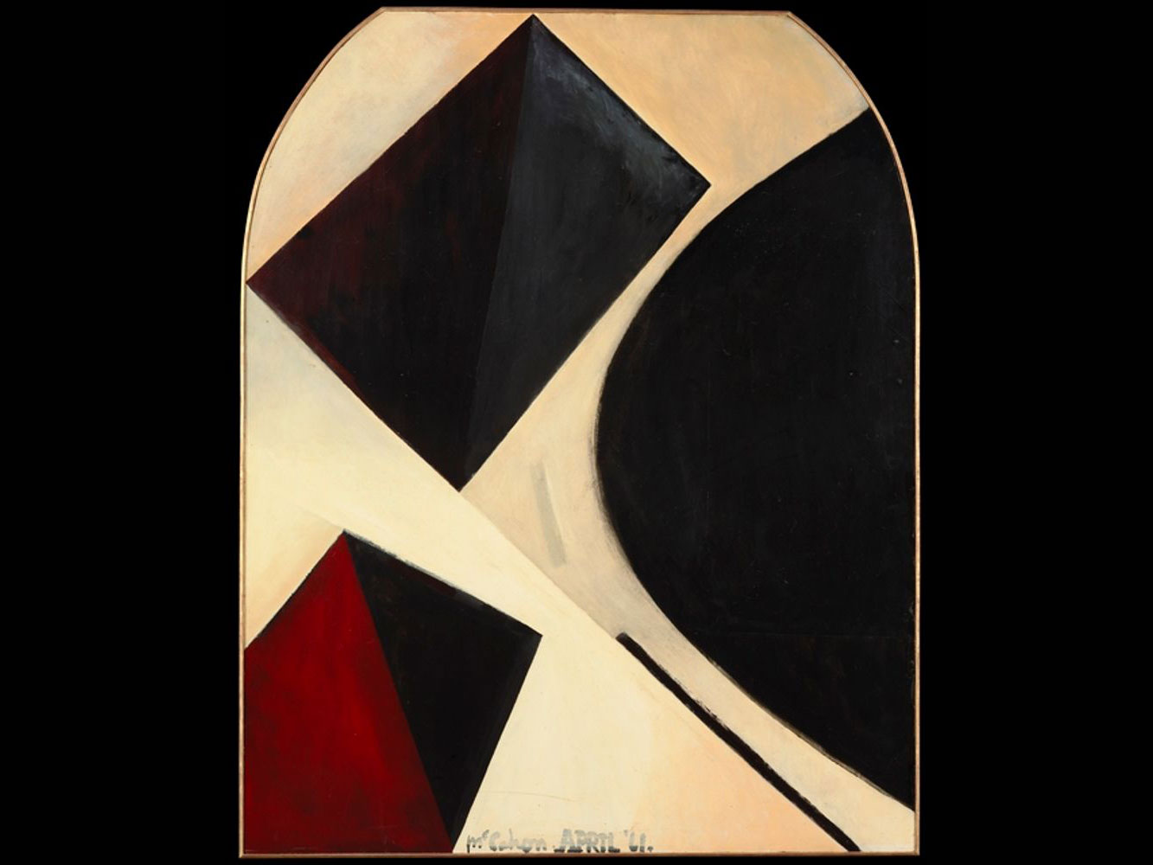
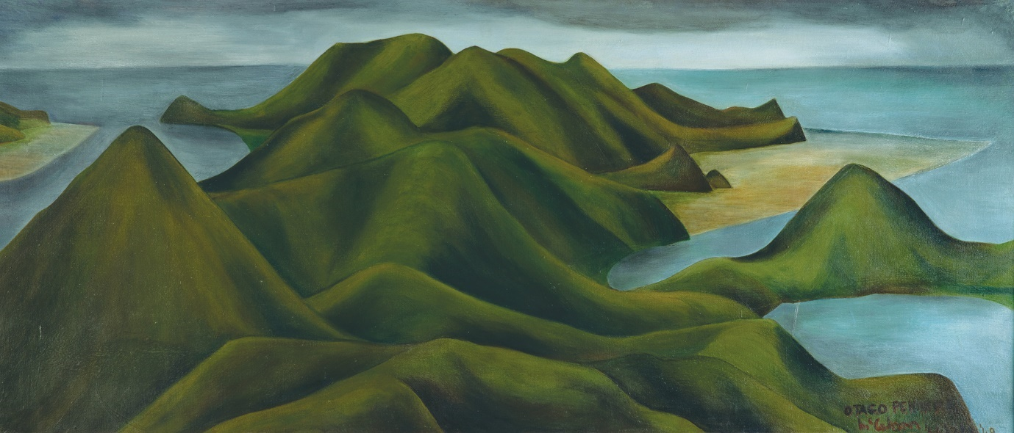

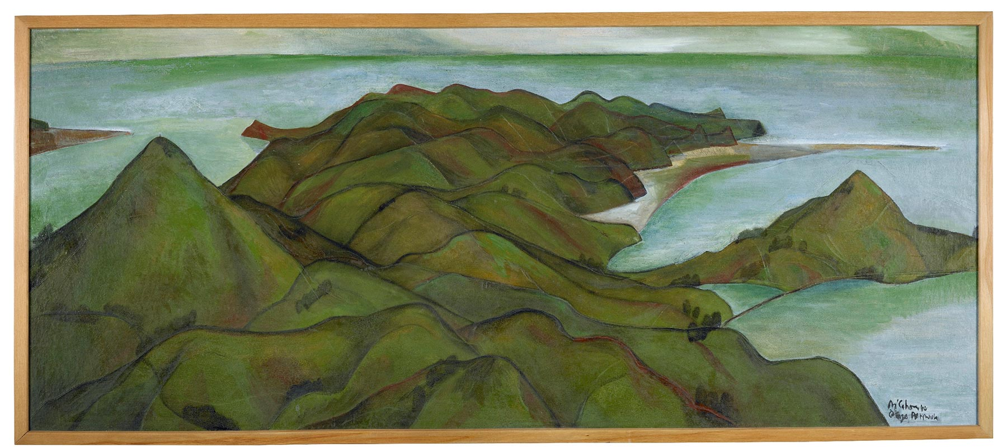
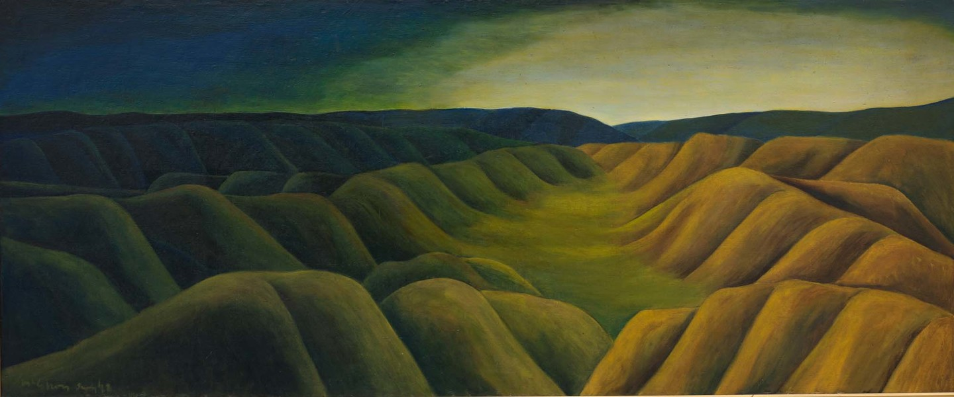
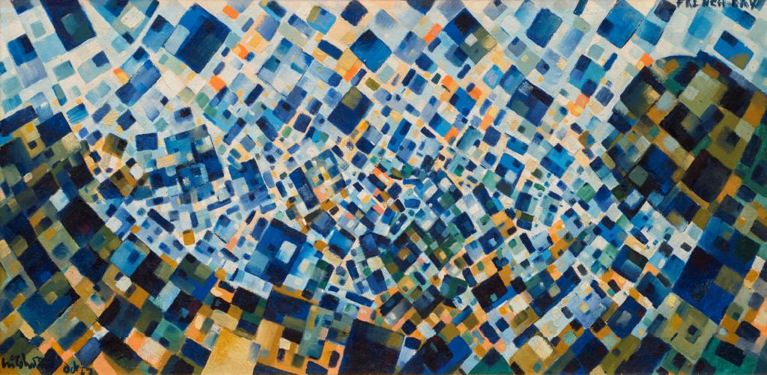

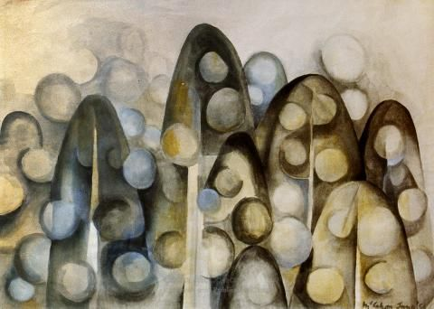

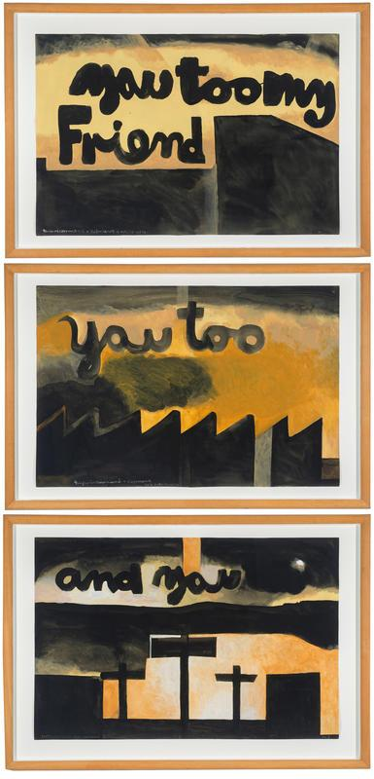
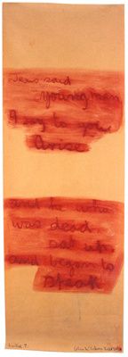

Station 12 James K Baxter: Exploring his life
Read of James’ life and reflect on the way the Holy Spirit was at work in him…
Background to James K. Baxter
James K. Baxter was born in Dunedin 29 June 1926. His father Archibald Baxter. was a farmer, and a well-known conscientious objector in WW1. His mother studied Latin, French and German at the Universities of Sydney and Cambridge. When James was ten and already writing poetry, his family moved to Whanganui. A year later they moved to England, where he attended a Quaker boarding school.

Aged thirteen, James and his family returned to Dunedin. He continued to write while a student at Otago University but didn’t complete his degree due to his drinking. At 18, he too became a registered conscientious objector, citing religious and humanitarian grounds. His struggles with alcoholism began in these early years. He married a young Māori student Jacquie Sturm in 1948, and his developing interest in Christianity culminated in his baptism in the Anglican church in Napier that same year. In 1951 they moved to Wellington and James enrolled at Teachers’ College. He taught in Lower Hutt and by then they had two children. James joined Alcoholics Anonymous and finished his BA from Victoria University. An inheritance enabled them to buy a house in Wellington, and James moved from teaching to writing and editing primary school bulletins for the Dept of Education. In 1957 James took a course on Roman Catholicism where he discovered a new way of faith, dismaying his Anglican wife and in part leading to their separation. In 1958 he was baptised into the Roman Catholic church. He then went to India under a UNESCO stipend to study educational publishing and while there, reconciled with his wife. On his return to NZ he was more concerned with Māori displacement.

In 1963 he resigned from the Dept of Education and became a postman to support his writing, which was becoming more powerful and prolific. In 1966 he took up the Robert Burns Fellowship at Otago University which eased his money worries. In this time, many of his plays were staged and he joined the anti-Vietnam War protests.

In 1968 he was instructed in a dream to “Go to Jerusalem”. In 1969 he left the university and a job composing catechetical material for the Catholic Education Board, spent some time in preparation by setting up a drop-in centre for drug addicts in Auckland, then went to the small Māori settlement of Jerusalem on the Wanganui River with nothing but a Bible. There he established a commune structured around “spiritual aspects of Māori communal life”. It was a sparse and isolated existence, travelling into nearby cities to work with the poor and speak out against poverty. The commune grew to about 40 permanent residents, mainly aged 16-25 years and they had over a thousand visitors each year. This brought increasing reaction and opposition and by 1971 the commune was disbanded. James returned to Wellington, but a year later was allowed to return to Jerusalem, provided no more than 10 people lived on the land at any one time. This all took a toll on James’ health and by 1972 he was too ill to remain in Jerusalem and moved to another commune near Auckland. On 22 October 1972 he suffered a coronary thrombosis in the street and died in a nearby house, aged 46. He was buried in Jerusalem in a ceremony combining Māori and Catholic traditions.

Station 13 The Māori Jesus by James K Baxter
I saw the Māori Jesus
Walking on Wellington Harbour.
He wore blue dungarees,
His beard and hair were long.
His breath smelled of mussels and paraoa.
When he smiled it looked like the dawn.
(the first lines of Baxter’s The Māori Jesus)

In 1968 when he spoke to the National Council of Churches about his spiritual journey, James told of a time in the late 1950s, when he began visiting alcoholics in a Salvation Army home in Wellington, he found Christ “sitting at the desk in Army uniform”.

He shared his understanding of how the Christ of love is with us, but Love cannot remain inactive. It must be expressed in works of mercy. So, he saw it as a cause for joy that there were so many works of mercy open before us –
“Alcoholism, mental illness, the difficulties of youth, the loneliness of age, war and the effects of war, disruptions of family life, poverty that is not the Gospel poverty but something thrust on people by the injustice of others – these are indeed our challenge and our opportunity”.

For James, it was in overcoming our own sense of security and comfort in order to act out this love, that we get to see Christ in ourselves or in others:
“Christ was poor and we are rich. Our riches beget the fear that someone will take them away from us. For once that He warned us against impurity, Our Lord warned us a thousand times against undue attachment to physical and mental possessions. Let us be poor then: poor followers of a poor and crucified Master. We stuff ourselves and our children with ice creams, while Asian and Biafran children crawl into ditches to die. We worry about the doubtful purity of our adolescents, forgetting that we have already trained them, by our example, to look for the meaning of life in some kind of material security. What security in fact have we? Only love.”

His conclusion was that “Christianity is not the discovery of a mathematical secret. Where love is, God is.”

For James, Christ, God’s son, is only dimly present in the boardroom or the parliamentary debating chamber or the places where the powerful make decisions. In contrast, God is most visibly present in places which we associate with defeat: the homeless who not infrequently find that Christ is beside them, looking into their eyes, listening to their complaint, and saying: ‘A little while. Just a little, and you and I will never be parted.’ We do not often have that consolation, he argues, because we have already decided that our security comes from material possessions.

- Who might the Holy Spirit be asking you to look at and see Christ in?

Station 14: PowerPoint

– Have James K Baxter’s Song to the Holy Spirit on the slide show. Have a handout for reflection on it available.

(NB: I find it useful to have one space where people do not have to move, especially if it is a new activity for folk)

Song to the Holy Spirit – James K Baxter

Lord, Holy Spirit,
You blow like the wind in a thousand paddocks,
Inside and outside the fences,
You blow where you wish to blow.

Lord, Holy Spirit,
You are the sun who shines on the little plant,
You warm him gently, you give him life,
You raise him up to become a tree with many leaves.

Lord, Holy Spirit,
You are as the mother eagle with her young,
Holding them in peace under your feathers.
On the highest mountain you have built your nest,
Above the valley, above the storms of the world,
Where no hunter ever comes.

Lord, Holy Spirit,
You are the bright cloud in whom we hide,
In whom we know already that the battle has been won.
You bring us to our Brother Jesus
To rest our heads upon his shoulder.

Lord, Holy Spirit,
You are the kind fire who does not cease to burn,
Consuming us with flames of love and peace,
Driving us out like sparks to set the world on fire.

Lord, Holy Spirit,
In the love of friends you are building a new house,
Heaven is with us when you are with us.
You are singing your song in the hearts of the poor.
Guide us, wound us, heal us. Bring us to the Father.

- What other images of the Holy Spirit are you familiar with?

An extra station for young ones…
At this station have
- some playdough (the simplest way is purchase Play-do’s party pack with its small containers of lots of colours, $10 @ The Warehouse),

- some paper and coloured pens/ felt tips/ pencils

- and the following pictures to colour

Children are then invited to explore the way God works in them by sculpting, drawing or colouring. This can be as free or as guided as you wish.
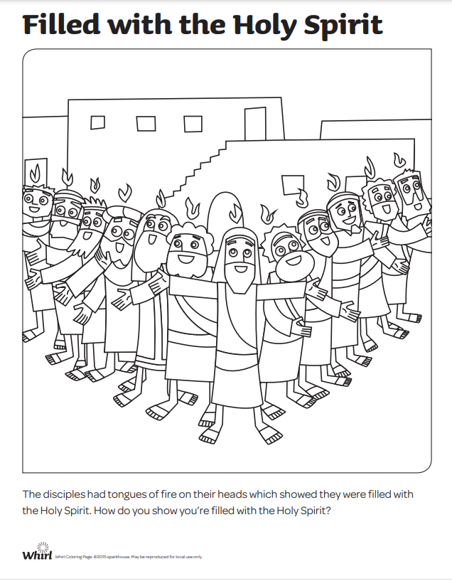

Regathering…
Song: Spirit, come
Written by Margaret Tooley and offered for you to sing

Bible Reading: John 14: 8-27
Concluding comment
Here in this text we see the role of the Spirit as Advocate. We were never left to do this alone. This huge task of loving is done in the power of the Holy Spirit.
In the lives of James Baxter and Colin McCahon we see imperfection. We see struggle and sin and doubt and disappointment. But we also see hope. Their faith, however weak, was present.
As Leonard Cohen sings, “forget your perfect offering, there is a crack in everything, that’s how the light gets in”.
Even in their weakness, we see God. Such real and grounded faith that continued to grapple, is no collapse of faith. It is faith amidst darkness.
And that gives us hope. That God will use us too, amidst all our failings. Amidst the way we too are misunderstood. We too can be a work in the hand of God, through the power of the Holy Spirit, so to become more like Christ.
Play Leonard Cohen’s ‘Anthem’
https://nz.video.search.yahoo.com/search/video?fr=mcafee&ei=UTF-8&p=Anthem+Leonard+Cohen&type=E210NZ105G0#id=2&vid=1816f79776e2883f1a83822a166b08a5&action=click
Fade the sound at about 5 min 40 seconds… (or earlier if you prefer)
Prayers of Intercession: Building Blocks of The Kingdom
In this act of prayer, O God
Our lives are opened to You, and with them, our world.
We pray that Your Spirit
would whisper through every heart and every place
where the voice of Your Presence is silent.
We ask that Your Spirit
would challenge and empower
all who are weak, broken, diseased or weeping.
We long for Your Spirit
to inspire all who follow You
to think, speak and live as true imitators of Christ
That our world and all who live in it
may know peace, healing and reconciliation with you and with each other.
Bless us, O Lord,
that we may become the building-blocks of Your Kingdom among us.
In Jesus' Name. Amen.

~ by John van de Laar © 2006 Sacredise.com
.
Or
Prayers of the People for Pentecost with sung response (more information below)
Great God, you wrap us round with love, like a mighty, gentle mother,
and you carry us like a strong and tender father,
setting us on our feet to be your free, mature and joyful daughters and sons.
Now, in our weakness, we pray to you
because we cannot come through life’s troubles unscathed;
and, with souls and bodies stressed and strained,
we cannot meet each other’s needs without your Holy Spirit.
Holy Spirit, come with healing power;
Spirit, gift of Christ, fill us with us God’s love.
Great God, we come to you with the resurrected Christ,
who bore the weight of human flesh and blood to Calvary, for your love’s sake;
and even now, as conqueror of death,
he pleads with you for all your suffering children.
Holy Spirit, come with healing power;
Spirit, gift of Christ, fill us with us God’s love.
We join our prayers to the prayers of Christ
for those we know who are ill or troubled,
and for all your suffering children who are beyond our reach of mind:
we know that all are brought home to your heart
in the prayers of Christ
and in the silent intercessions of your Spirit,
who comes from your deep heart to ours,
and returns again to you with all our deepest longings.
Holy Spirit, come with healing power;
Spirit, gift of Christ, fill us with us God’s love.
Heal us and help us, comfort and strengthen us, deepen our joy.
Let our love reflect your might tenderness and serve you healing gentleness.
Holy Spirit, come with healing power;
Spirit, gift of Christ, fill us with us God’s love.
Eternal God, there is great longing in the world;
people are desperate because of the suffering they endure.
Earth cries out for peace; oppressed people cry for justice;
women, men and children weep in sorrow and pain.
How can we have any hope for the world,
unless you are with us?
Through all the mystery of pain, sorrow and human vulnerability,
we dare to believe that you are on our side,
that your love for us is greater than ours for you or for each other.
Call us, then, to prophesy!
By the lives we live, by our patience, by our compassion,
by our belief in the future you will make for us,
let your Church proclaim the great things you are doing,
with hope for the nations of the world,
for every person born, and every living creature.
Holy Spirit, come with healing power;
Spirit, gift of Christ, fill us with us God’s love.
So, Living God, let praise begin, here and now with us,
welling up from our hearts,
rising towards the skies,
until praise fills the universe and joy is unconfined:
as you delight in us and we delight in you, for evermore.
— Alan Gaunt, © 2005.
The congregational response (in italics above) can be sung to the melody of the Taize chant, Ubi Caritas.
One of many Prayers for Pentecost posted on the United Reformed Church website—be sure to check them out. The website suggests that these prayers “may be freely used by local churches and individuals in their worship. It may not be resold in any form or used for any commercial purpose without the prior permission of the author.”
Song: Amazing Grace
Benediction May the grace of our Lord Jesus Christ, the love of God, and the fellowship of the Holy Spirit, be with you now and always, Amen.
Or have a packet of popping cany attached to the order of service and now invite people to open it and have a taste.
This one you can order from Look Sharp stores.

As you let the candy pop in your mouth, reflect on the way the Spirit changes us from the inside. And so, invigorated by the refreshing wind of the Spirit, and inflamed with the fire of Divine love, face this new week with expectation, that the Holy Spirit will move in you, bubbling up inside you and overflowing in love and kindness, in surprising ways, Amen
© Nikki Watkin, 2022

